# CSCE590 Project report: MyOffCampus App

Shannon Hood, Ming Wong, Kelly Benson

Department of Computer Science & Engineering

University of South Carolina, 04/28/2016

**The problem:**

Students have a hard time finding off campus living after their first year at USC. Many students also have bad experiences their first year living off campus because accurate reviews of off campus housing are hard to find. Many landlords do not maintain their properties and often keep security deposits for little to no reason. Sometimes they even change the terms of the lease, such as the cost of electricity, mid-lease. So students may think the property is bad, when in reality both the landlord and the property are at fault.

**The solution:**

MyOffCampus allows students to rate and review landlords and properties. They can search for somewhere they are thinking about living, or search for somewhere they currently live to leave a review. If they are searching for an apartment or place to live, they can then sort the results by rating or alphabetically. The user can see the location of the property on google maps on the property’s page, or what properties are owned by a landlord on the landlord’s page. Users can also save properties and landlords they are interested in for viewing later. If a person cannot find the property or landlord they are looking for, they can add the property or landlord and then leave a review for others to see. This app aims to give more information to students to enable them to make better and easier choices in the hunt for off campus living.

**Screenshots of the App:**

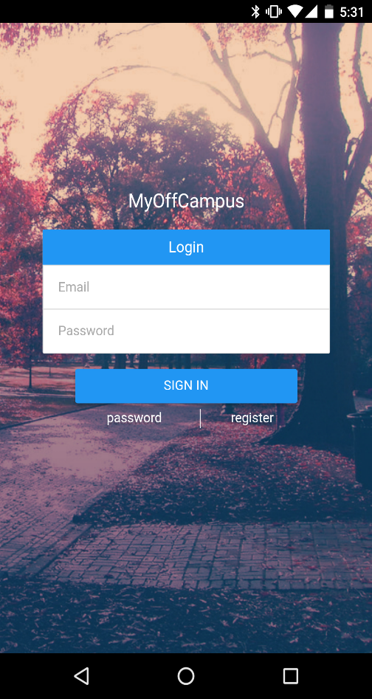 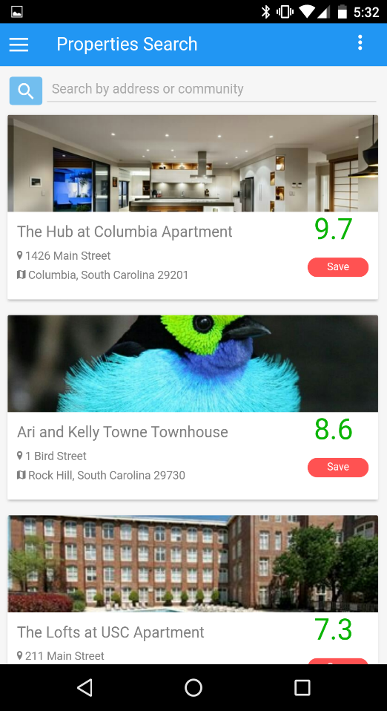 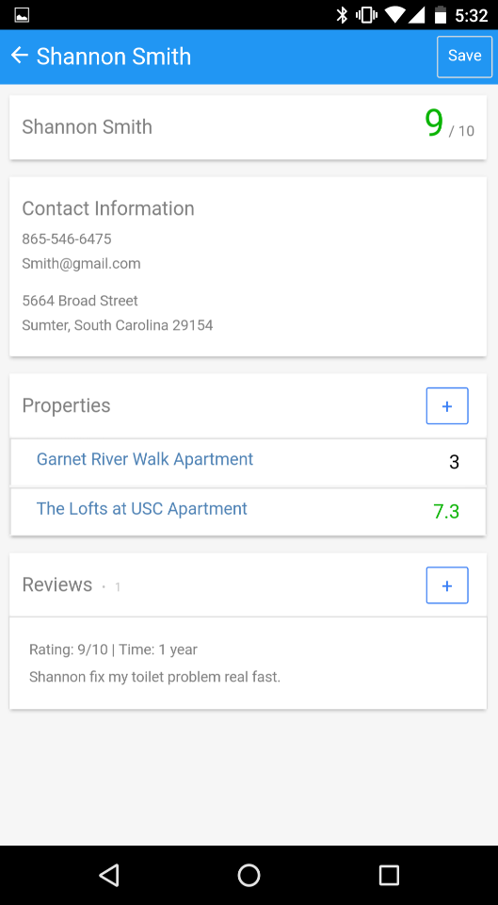

**Contributions:**

Shannon worked on both the front and backend of the login, register, saved properties and saved landlords pages. She also debugged and improved most of the front end. Ming worked on the add property and property feed pages. She also did most of the backend work for the app. She fixed the iPhone bug. Kelly did the initial rough draft of most views of the app. She also met with the sponsors regularly.